Repeater

🔁 What is a Repeater in Networking?
# Source: AI Source: Provided by: [Data Path: Persons Table -> ID Column: 1, Name_En Column: Motasem Essam] -> From: [ChatGPT] on [12/18/2025]
A Repeater is a Layer 1 (Physical Layer) device that is used to regenerate and amplify network signals so they can travel longer distances without degrading. It receives a weak or distorted signal, cleans it up, and retransmits it.
✅ A repeater does not interpret or manage data — it simply strengthens the signal.

🔧 What a Repeater Does
# Source: AI Source: Provided by: [Data Path: Persons Table -> ID Column: 1, Name_En Column: Motasem Essam] -> From: [ChatGPT] on [12/18/2025]
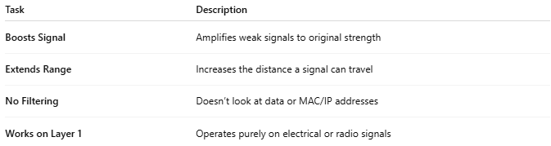
Task | Description
Boosts Signal | Amplifies weak signals to original strength
Extends Range | Increases the distance a signal can travel
No Filtering | Doesn’t look at data or MAC/IP addresses
Works on Layer 1 | Operates purely on electrical or radio signals

📶 Example Use Case
# Source: AI Source: Provided by: [Data Path: Persons Table -> ID Column: 1, Name_En Column: Motasem Essam] -> From: [ChatGPT] on [12/18/2025]
Ethernet Repeater:
If Ethernet signal length exceeds 100 meters:
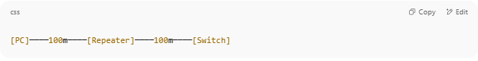
[PC]────100m────[Repeater]────100m────[Switch]

Wi-Fi Repeater (aka Wireless Extender):
Extends wireless coverage:
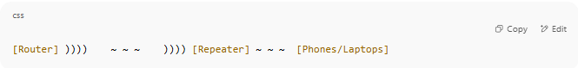
[Router] )))) ~ ~ ~ )))) [Repeater] ~ ~ ~ [Phones/Laptops]

🧠 Types of Repeaters
# Source: AI Source: Provided by: [Data Path: Persons Table -> ID Column: 1, Name_En Column: Motasem Essam] -> From: [ChatGPT] on [12/18/2025]
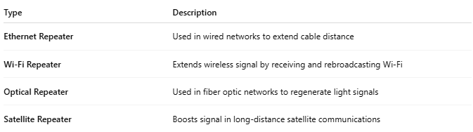
Type | Description
Ethernet Repeater | Used in wired networks to extend cable distance
Wi-Fi Repeater | Extends wireless signal by receiving and rebroadcasting Wi-Fi
Optical Repeater | Used in fiber optic networks to regenerate light signals
Satellite Repeater | Boosts signal in long-distance satellite communications

🆚 Repeater vs Other Devices
# Source: AI Source: Provided by: [Data Path: Persons Table -> ID Column: 1, Name_En Column: Motasem Essam] -> From: [ChatGPT] on [12/18/2025]
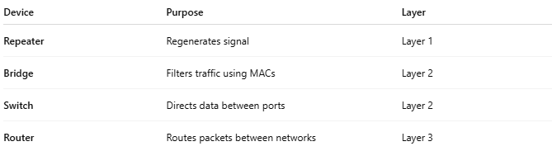
Device | Purpose | Layer
Repeater | Regenerates signal | Layer 1
Bridge | Filters traffic using MACs | Layer 2
Switch | Directs data between ports | Layer 2
Router | Routes packets between networks | Layer 3

✅ Pros
# Source: AI Source: Provided by: [Data Path: Persons Table -> ID Column: 1, Name_En Column: Motasem Essam] -> From: [ChatGPT] on [12/18/2025]
- ✅ Simple and low-cost
- ✅ Great for extending signal over long distances
- ✅ Works with both wired and wireless networks

❌ Cons
# Source: AI Source: Provided by: [Data Path: Persons Table -> ID Column: 1, Name_En Column: Motasem Essam] -> From: [ChatGPT] on [12/18/2025]
- ❌ No traffic management (can forward noise)
- ❌ Adds latency in some wireless setups
- ❌ In Wi-Fi, it halves bandwidth on rebroadcast

📌 Summary
# Source: AI Source: Provided by: [Data Path: Persons Table -> ID Column: 1, Name_En Column: Motasem Essam] -> From: [ChatGPT] on [12/18/2025]
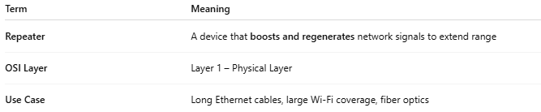
Term | Meaning
Repeater | A device that boosts and regenerates network signals to extend range
OSI Layer | Layer 1 – Physical Layer
Use Case | Long Ethernet cables, large Wi-Fi coverage, fiber optics

